Here, we will take the program in the folder “DataAndModel” as an example.

**Notations:**

**The Matlab's version is R2016b;**

Parameter.mat: The related parameters and feasible solution;

Model.slx: The system is built by Simulink;

Plot_Figures.m: The relevant datas in Simulink are used to plot the figures for this paper.

**Step 1.** In the Command Window, please input

“load('Parameter.mat')”

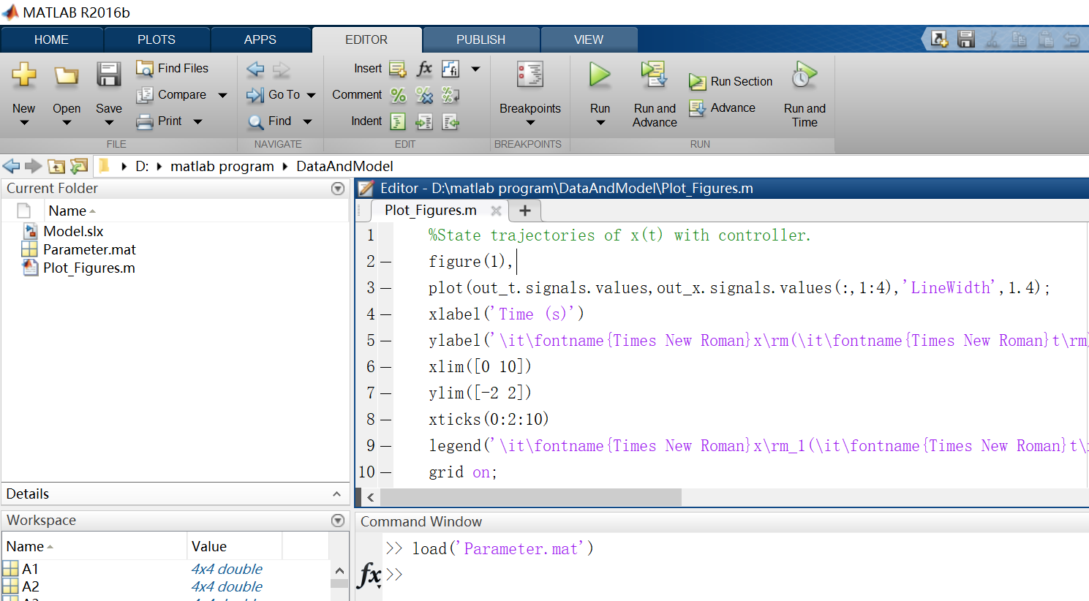

**Step 2.** Open the file “Model.slx”. Click “Run” for the file “Model.slx”;

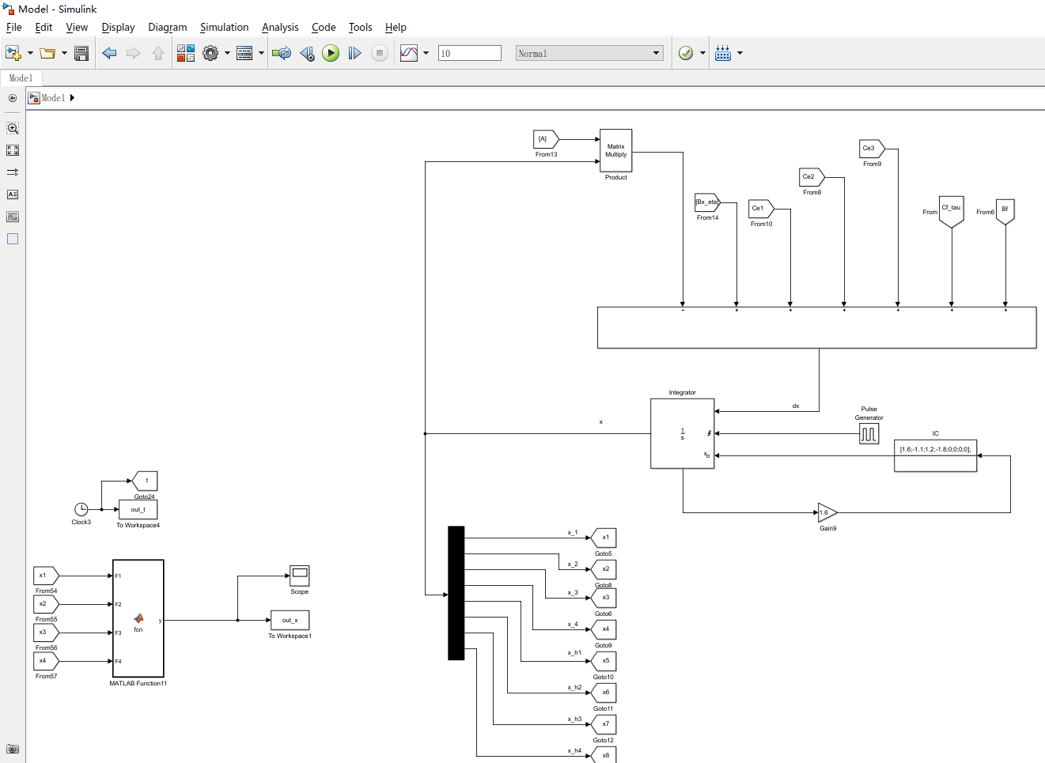

**Please kindly note that the higher version of Simulink can open a lower version of the Simulink view, but the lower version of Simulink cannot open a higher version of the Simulink view.**

**If your MATLAB version is below R.2016b, skip this Step 2. Then perform Step 2.1. (To enable you to run the third step smoothly and check the simulation, we have saved the data for you after Simulink running. The data is named as “SaveParameterFromSimulink.mat”.)**

**Step 2.1.** In the Command Window, please input

“load('SaveParameterFromSimulink.mat')”

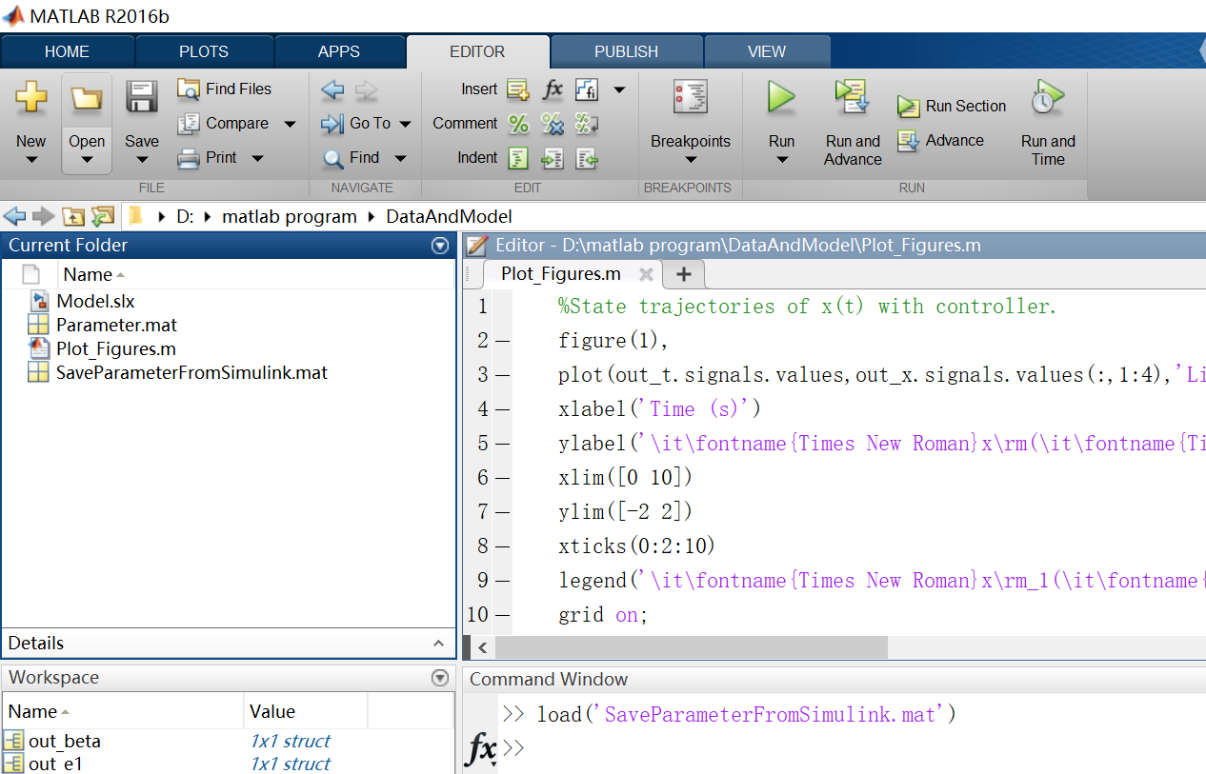

**Step 3.** Open the file “Plot_Figures.m”. Click “Run” for the file “Plot_Figures.m ".

